**CS5404 Assignment 2**

**Wei Luo**

1. **Summarize what you think the assignment was about (what was the task; what were you trying to achieve).**

Corner detection is an approach used within computer vision systems to extract certain kinds of features and infer the contents of an image. The assignment is about to build a Harris Corners Detector. With this detector, we can find the corners on the images.

1. **Run your program and show pictures of intermediate and final results that convince us that the program does what you think it does.**

I set the S = 1, N = 3, D = 11, M = 100 for these three images. (run test.m to get the results)

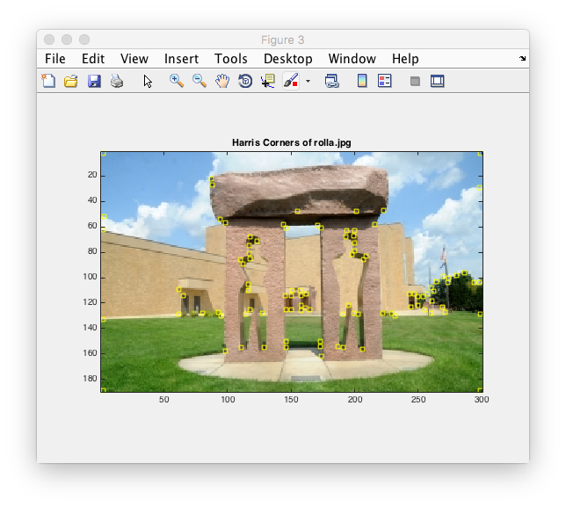

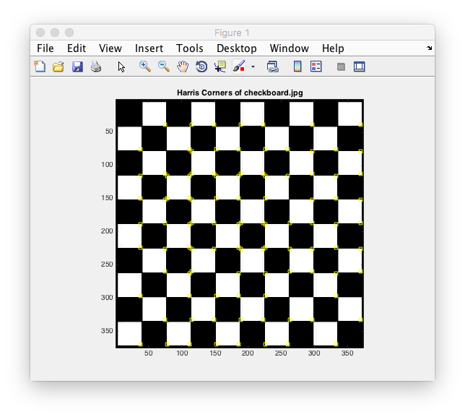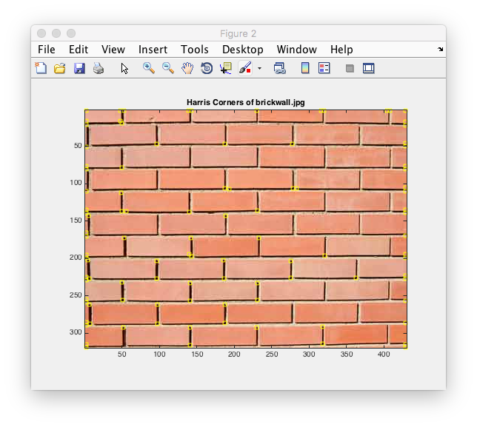

the Harris R images:

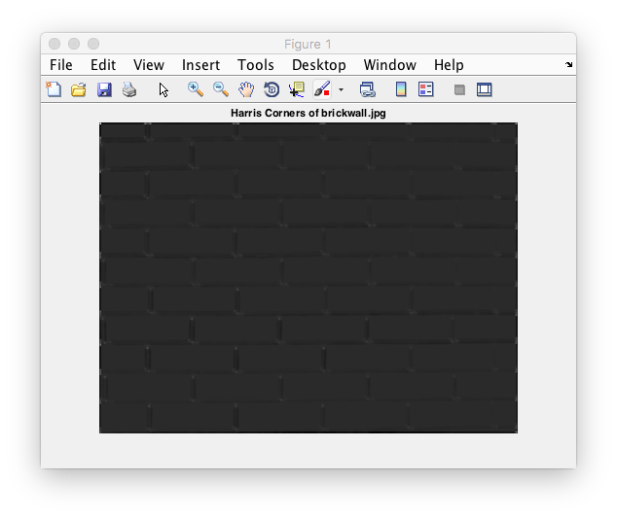

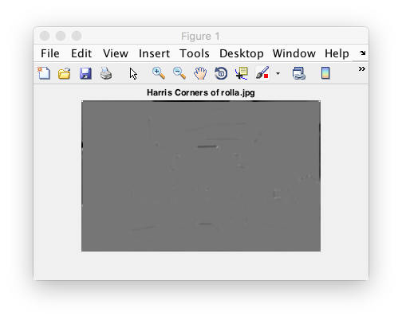

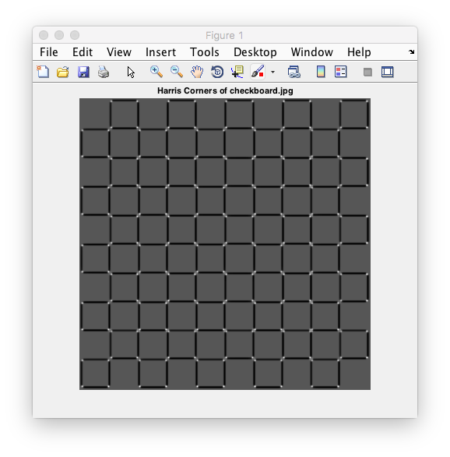

1. **Explain any design decisions you had to make.**

We set the sigma as 1, because I think we do not need to smooth these three images to find the corners. And we set the D as 11, so that we would not get the nearby biggest R as two corners in the results. We set M as 100, in order to find 100 corners in these images. Besides, we set the size of Gaussian kernel as 6 times sigma, so that we can make the image smooth and not to lose our corners.

1. **Experimental observations.**

The function work well and I see the corners on the images as well.

In this section, I have try different value of Gaussian sigma. While the result is not well if I set the sigma larger and there is not much change if I set the sigma lower than 1. Besides, I set a little larger M for brickwall.jpg as 140 and I can got most corners on the image.

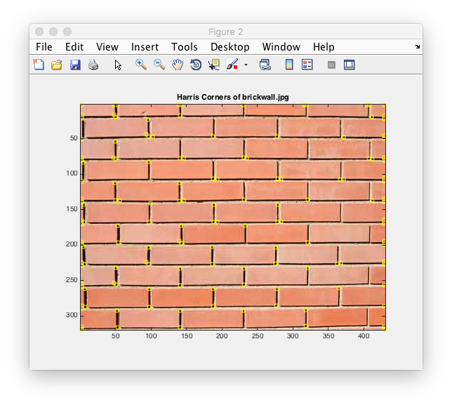

**bonus**

I set the S = 1, N = 3, D = 11, M = 100 for these three images, and the results is below.

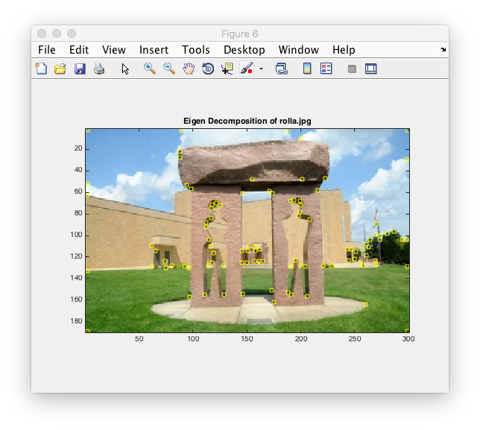

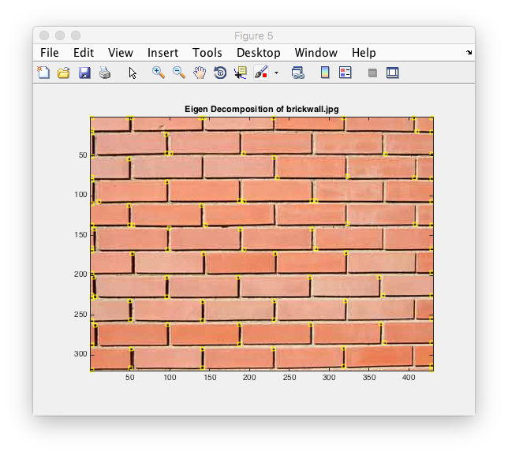

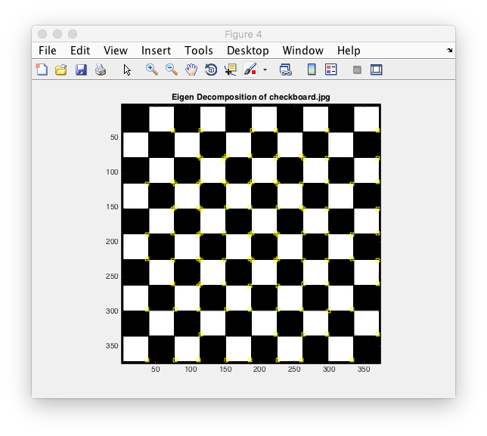

In my opinion, the Eigen Decomposition work well and the results are similar with the results of Harris Corners Detector. The difference between them is the Harris Corners transfer the images into R and find the best ones as corners. While the Eigen Decomposition transfer the image into to compute the corners. We use the checkboard.jpg as example.

The image of R is below.

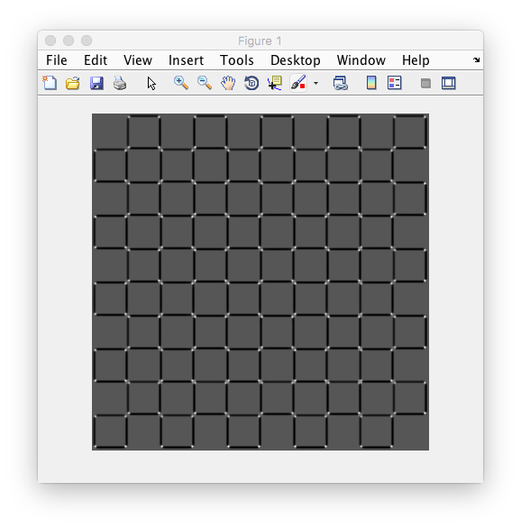

and the image of .

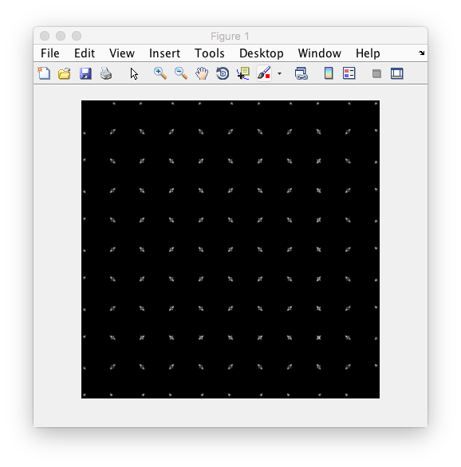

It is easily to found that they are similar for the best points.